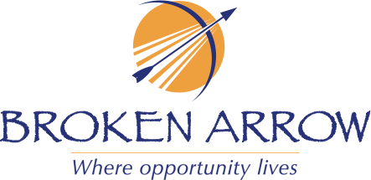

CERTIFICATE OF RECOGNITION
IN HONOR OF
Bishop William J. Cox
On behalf of the City of Broken Arrow, we wish you the very best on this momentous occasion. As you reflect upon 104 years of memories, I hope that you are filled with tremendous pride and joy.
Happy 104th Birthday
January 15, 2025

