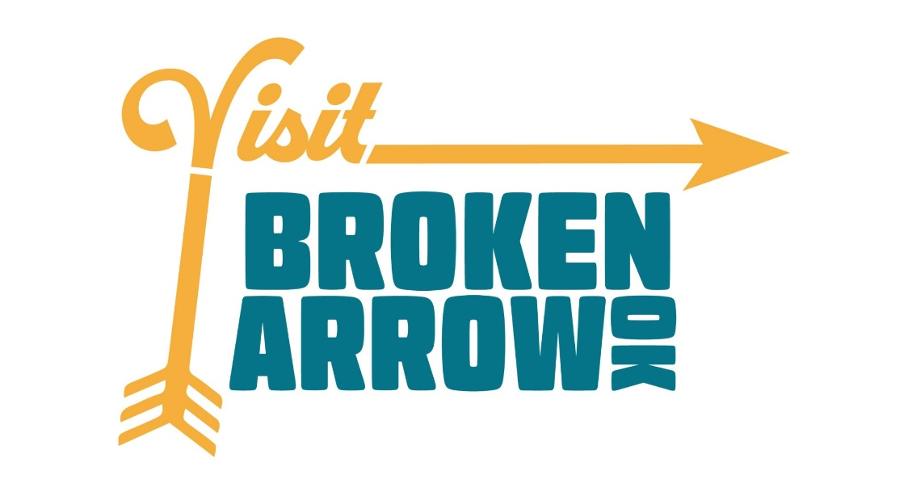

Visit Broken Arrow

Film Incentive Application

NOTE: All funding approvals are subject to the City of Broken Arrow’s annual appropriations. While it is understood that start and end dates may change, please note that all requests for reimbursement must be received by June 30 of the FY in which the application was approved. If the project is delayed into a future fiscal year, the application may have to go through the approval process again. Any changes must be submitted for approval to the Visit Broken Arrow staff immediately or Certification could be revoked.

APPLICANT INFORMATION
Application for fiscal year (6/30-7/1): ___

LEGAL NAME AND ADDRESS OF APPLICANT
Legal Name: Address: City/State/Zip: Contact Person: Title: Email Address: Phone:
Date of Incorporation or Formation: Federal Tax ID Number:

PRODUCTION COMPANY (if different than applicant):
Legal Name: Address: City/State/Zip: Contact Person: Title: Email Address: Phone:
Date of Incorporation or Formation: Federal Tax ID Number:

PARENT COMPANY (if applicable):
Legal Name: Address: City/State/Zip: Contact Person: Title: Email Address: Phone:
Date of Incorporation or Formation: Federal Tax ID Number:

PROJECT INFORMATION

Title of Project: ___________________________________________________

Type of Production:

Feature Film:
Cable TV Series, number of episodes? Season Number:
Network TV Series, number of episodes? Season Number:
Streaming Series, number of episodes? Season Number:

Is this project fully funded? yes no

Is the production company applying for certification as a ‘work for hire’ for another production company?
yes no

Did the production company applying for certification hire another production company as a ‘work for hire?’
yes no

Script Attached?: yes no

Please provide a description of this project (storyline):

Name of talent attached:

Where in Broken Arrow are you planning to film your project (list locations):

PRODUCTION INFORMATION
The production will be asked to update this information once principal photography starts.

Estimated total number of Broken Arrow residents to be hired on the Production:
cast, crew, extras

Wrap Date: Number of proposed shooting days in Broken Arrow:

Pre-Production Project Start Date: Principal Photography Start Date:

Post Production Start Date:
NOTE: To qualify, 25% of the shooting days must be in the City of Broken Arrow

Total Budget of Project:

Distribution Plan:

If television and commercial projects, which network?

Theatrical distribution plan in place?

Producer: | Phone:
Producer: | Phone:
Producer: | Phone:
Producer: | Phone:
Line Producer: | Phone:
Unit Production: | Phone:

Location Manager: Phone:

CREDITS AND PROMOTIONAL MATERIALS
To complete eligibility requirements, applicants will provide the following items:
- Signed consent form from the City of Broken Arrow
- Completed Film in BA Permit Application
- Signed IRS form W-9 for the applicant/production company
- Final versions of the crew and contact lists, budget, shooting schedule, production reports and vendor list (Film Only)
- Proof of funding, if needed
- Any and all documents required by the auditing accounting firm, if needed
- Five production still photos in electronic format with rights cleared for promotional use by the City of Broken Arrow/Visit Broken Arrow.
- An electronic press kit (Film/TV Series Only)
- One (1) poster of the type designed for promotion of the finished project (Film/TV Series Only)
- A digital copy of the finished project

I agree (Print Name and Signature)

The above information will be provided by: Name: Title: Company: Company Address: City/State/Zip: Email Address: Phone:

The end credit roll of a full-length picture that utilizes the Visit Broken Arrow Film Incentive rebate must recognize the City of Broken Arrow and requires use of the Visit Broken Arrow/Film in Broken Arrow logo. The City of Broken Arrow/ Visit Broken Arrow reserves the right to refuse use of its logo(s) in the credits of a motion picture filmed or produced in the City of Broken Arrow.
Authorized Signature: Date:

Contact Information for Post
Legal Name: Address: City/State/Zip: Contact Person: Title:

Email Address: Phone:

GUIDELINES

Incentive | Requirements | Rebate
Project Incentive  - Feature Films  - TV Series  - Commercials | - Minimum budget of $5,000  - Minimum spend equal to 10% of total budget amount in Broken Arrow City Limits (hotels excluded due to separate hotel room incentive, below)  - 25% of shooting days/time must be in Broken Arrow  - Pre-completed/approved Visit Broken Arrow filming permit if required  - Display the Visit Broken Arrow logo in end credits | 10% rebate of qualified spend
Hotel Room Incentive | - In addition to the above, all project types above are eligible to receive $500 for every 12 room nights stayed in a Broken Arrow hotel. Documentation must be provided. | $500 for every 12 room nights
Production Office Incentive | - Assistance in identifying production office space in Broken Arrow City Limits  - Minimum budget of $xx,xxx and minimum office need of 1 week (7 days). | TBD
City of Broken Arrow Film Incentive Caps and Estimated Costs
Up to $XXX,XXX will be made available for the incentive fund on an annual basis beginning July 1 and expiring June 30. The fund will be reviewed on an annual basis by Visit Broken Arrow staff, the Visit Broken Arrow Board of Directors and other appropriate City of Broken Arrow leadership and will be subject to the City of Broken Arrow annual budget process. Funding is available based on a first come, first serve basis. Each funding application will be reviewed by Visit Broken Arrow staff for eligibility and must be approved by the Visit Broken Arrow Board of Directors. The incentive is available on a reimbursement basis upon completion of the production and an independent audit.

Other Information
- The expense of hiring a qualified 3rd party firm to manage verifications and accounting
of this incentive program is included in the totals allocated each year and not in addition to it.
- Preference given to family friendly films.
- The City of Broken Arrow has the right to reject any incentive application without reason.

Areas of production which qualify for local spending

Site rentals | Labor | Rentals | Purchases
Hotels | Gas and Oil | Catering | Craft service
Gratuities | Animals | Security, police | Health care professionals
Any crew that is hired locally and is paid, not volunteer.

CERTIFICATION BY APPLICANT
I/we have read and understand the City of Broken Arrow/Visit Broken Arrow Film Incentive Guidelines. __ yes
- Production must be scheduled to begin principal photography within 6 months of application.
- Production must meet with Visit Broken Arrow staff prior to applying.
- Only one production company per project may receive certification for the rebate. In the instance of a work-for-hire, the work-for-hire company will not be eligible for the rebate.
- Project budget, including anticipated percentage of budget to be spent in the City of Broken Arrow must be submitted along with this application for the application to be considered complete.

Applicant is responsible for accuracy of all data and documentation included in this application. Initial appli- cations are submitted to Visit Broken Arrow staff. Once submitted, applications become the property of the City of Broken Arrow. It is the applicant’s responsibility to inform Visit Broken Arrow staff in the event there are changes to any information on the application. Amendments must be sent via email Visit Broken Arrow staff.
Upon written request, applicants shall issue any necessary authorization to the appropriate Federal, State or local authority for the release of information concerning a production being considered under these administrative rules, including but not limited to financial reports and records relating to the applicant or to the production for which this rebate is requested.
By signing below, the applicant certifies that all the information contained herein and exhibits attached here- to are true to the best of their knowledge and are submitted for the purpose of obtaining rebate through the City of Broken Arrow.

Applicant Signature: Date: Title: Phone:

Submit Applications to: Visit Broken Arrow
Email: visitba@BrokenArrowok.gov
Mail:
c/o Visit Broken Arrow
123 N Main Street
Broken Arrow, OK 74012
In Person:
123 N. Main St. Broken Arrow, OK

