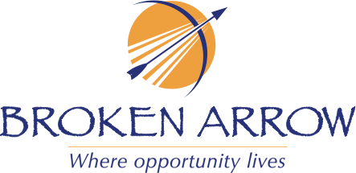

CERTIFICATE OF RECOGNITION
IN HONOR OF
Broken Arrow High School Girls Wrestling Team
The Broken Arrow High School Girls Wrestling Team has come up through the ranks to currently being named No. 5 in the Nation and No. 2 in Oklahoma. Some of the recent successes of this girls wrestling team during the 2024-2025 season are:
Jay Border Wars - Team Champions; Wrestle Like a Girl Cache - Team Champions; Diamond Duals TX - Team Champions;
Wonder Women MO - Team Champions; Alpha Female Tournament CO - Team Champions

Additionally, Emily Beckley is currently ranked No. 15 in the Nation.

